**Name ……………………………………………………….…. Centre/Index No………/………**

***Signature ………………………………………………***

**535/1  
PHYSICS   
Paper 1**

PHYSICS   
**Paper 1**2 hours 15 minutes

**INSTRUCTIONS TO CANDIDATES**

* Write your name, centre/Index number and signature in the space above
* Section A contains 40 objective type questions. You are required to write the correct answer A,B,C or D in the boxes at the right hand side
* Section B contains 10 structured questions. Answers are to be written in the spaces provided on the question paper.
  + Acceleration due to gravity = 10ms – 2
  + Specific heat capacity of water = 4200Jkg – 1 K – 1

**For Examiners’ use only**

|  |  |  |  |  |  |  |  |  |  |  |  |
| --- | --- | --- | --- | --- | --- | --- | --- | --- | --- | --- | --- |
| **Qn41** | **Qn42** | **Qn43** | **Qn44** | **Qn45** | **Qn46** | **Qn47** | **Qn48** | **Qn49** | **Qn50** | **MCQ** | **Total** |
|  |  |  |  |  |  |  |  |  |  |  |  |
|  |  |  |  |  |  |  |  |  |  |  |  |
|  |  |  |  |  |  |  |  |  |  |  |  |

**SECTION A :( 40Marks)**

*Answer* ***all*** *questions in this section.*

1. In the crushing can experiment, the can collapses because
2. It is weakened by the hot water
3. Pressure outside is greater than pressure inside
4. Pressure inside is greater than pressure outside
5. Pressure inside is atmospheric.
6. Light waves differ from sound waves because
7. light is an electromagnetic weaves
8. light waves are long and sound waves are short
9. Interference is obtained with light waves but not with sound waves
10. the speed of light is independent of the medium in which it travels
11. Find the velocity ratio of an inclined plane of length 12m if the height from the ground is 3m.
12. 6 B. 2 C. 4 D. 3
13. How much heat energy is required to raise the temperature of 50g of aluminum form 1000c to 1200c( specific heat capacity of aluminum =880Jkg-1K-1)
14. 4.4 x 103J
15. 9.68 x 103J
16. 5.28 x 105J
17. 8.8 x 105J
18. 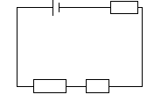 2V 1Ω

3Ω

2Ω

**Fig 1**

The potential difference across the 3Ω resistor in fig **1**is

1. 0.1V B. 0.5V C.1.2V D.1.0V
2. Which one of the following is true about the periodic time in a simple pendulum?
3. It is independent of the length of the string.
4. It increases with the length of the string.
5. It increases with mass of the bob
6. It is independent of amplitude.
7. Figure **2** shows a circular wave front approaching a straight barrier.

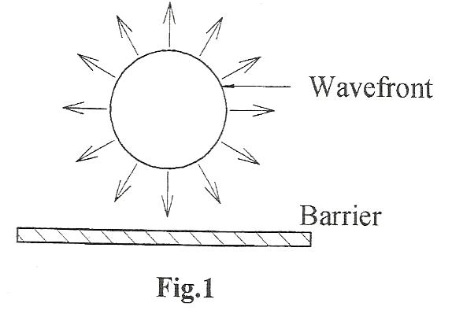

**Fig. 2**

Which one of the following diagrams shows the correct position of the wave front after reaching the barrier?

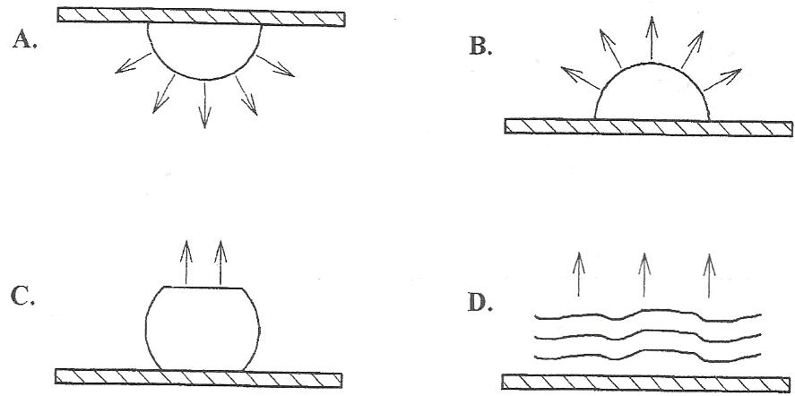

1. Electromagnets are used in the following **except** the
2. Telephone receiver
3. Moving coil loud speaker
4. Moving coil galvanometer
5. Electric bell.
6. Which of the following is/are true about cathode rays? They
7. are fast moving electrons
8. are electromagnetic waves
9. produce x-rays when stopped by heavy metals
10. (i) and (ii) only
11. (ii) and (iii) only
12. (i) and (iii) only
13. (i), (ii) and (iii).
14. A body starts from rest and accelerated uniformly at a rate of 8ms-2.Find the time it takes to cover a distance of 100m.
15. 5.0s B. 25.0s C.12.5s D. 3.5s
16. Water is preferred to ethanol to be used as a coolant because
17. Water has a higher density than ethanol
18. Water has a higher specific heat capacity than ethanol
19. Ethanol has a higher density than water.
20. Water is more volatile than ethanol.
21. An alternating current supply maintains a p.d of 600V across the ends of a coil having 200 turns as shown in fig **3**

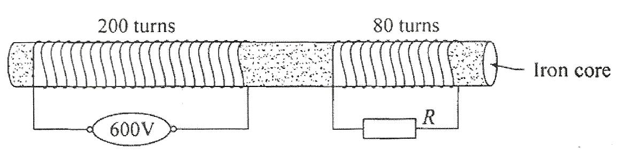

**Fig 3**

Find the p.d across the load R

1. C.
2. D.
3. Which of the following is true
4. magnetic lines of force are concentric
5. like poles attract.
6. magnetic lines of force cross at the neutral point
7. a single magnetic pole can’t exist.
8. In a loud speaker ,sound is produced by the
9. Soft iron core C. Coil
10. Metal casing D. Permanent magnet
11. Three forces act on a uniform rod as shown in figure 4

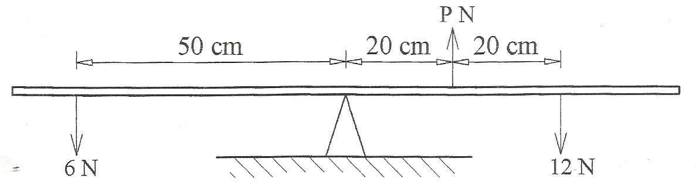

**Fig. 4**

If the rod balances horizontally, determine the value of p

1. 3N
2. 9N
3. 16N
4. 24N
5. When the terminals of a cell are joined directly ,the cell heats up because
6. a high current is drawn from the cell
7. the e.m.f is increased.
8. there is friction between the terminals
9. the internal resistance is raised.
10. A radioactive nuclide of atomic number P emits two alpha particles followed by beta particles. Find the atomic number of the resulting nuclide.
11. P + 1 C. P-3
12. P-1 D. P+3
13. Which one of the graphs shows a uniform deceleration of a car?
14. Velocity B. velocity

time time

Velocity

C D. velocity

time time

1. An electrical appliance rated 240V, 24W is run for 2 seconds. Find the current drawn by the appliance when in normal use.’
2. 0.1A C. 10.0A
3. 0.2A D.20.0A
4. Linear magnification is defined as the ratio of
5. Object distance to image distance
6. Object height to image height
7. Image distance to focal length
8. Image height to object height
9. When the key in the circuit in fig **5** is closed .the bare wire XY will

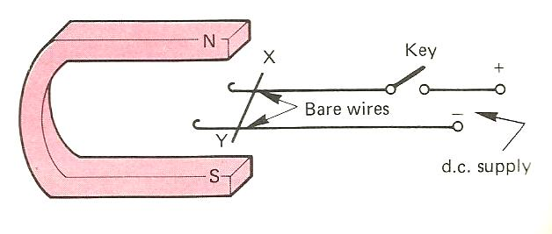

**Fig.5**

1. rise up off the bare wires
2. press down more strongly
3. move to the left
4. move to the right
5. The energy transformation that takes place when an electrophorus is used to charge bodies is
6. kinetic to potential
7. mechanical to electrical
8. mechanical to heat
9. heat to mechanical
10. Which one of the following is not a property of the image of an object placed 12cm in front of a plane mirror.
11. It is behind the mirror.
12. It is 12cm from the mirror.
13. It is real.
14. It is laterally inverted.
15. A student standing some distance from a vertical wall beats a drum. She hears the echo after 2 seconds .If the speed of sound in air is 330ms-1, find the distance between the walls.
16. 82.5 M B. 165.0M C. 330.0M D. 600M
17. A simple machine has a velocity ratio of eight and needs an effort 10N to lift a load of 50N. What is the efficiency of the machine?
18. 100% B. 62.5% C. 20% D.2.5%
19. The reason as to why a cathode ray oscilloscope is evacuated is to
20. minimize collisions of air molecules with emitted electrons
21. control the number of electrons reaching the screen
22. deflect the electron beam in both X and Y directions
23. Increase the brightness of waveform formed.
24. The lead-acid cell is called a secondary cell because;
25. Its output voltage is 2volts
26. It has two lead electrodes
27. It can be recharged
28. It must be topped up with distilled water.
29. Which of the following describes motion of molecules away from a liquid at a temperature below its boiling point
30. condensation
31. surface tension
32. boiling
33. evaporation
34. An object in unstable equilibrium continues to fall when slightly displaced because its
35. Centre of gravity is lowered
36. Center of gravity is raised.
37. Potential energy is reduced
38. Potential energy is increased.
39. (i) , (ii) and (iii) only.
40. (i) and (iii) only
41. (ii) and (iii) only
42. (iv) only
43. Current is measured by
44. a battery
45. a voltmeter
46. an ammeter
47. a motor
48. Diffraction is a property of light which shows that light is a
49. wave
50. vector
51. form of energy
52. form of matter
53. Which one of the following colours is used for the live wire in three core cables?
54. Brown
55. Black
56. Yellow
57. Blue
58. A school nurse applies a force of 30N to a syringe .Given that the cross sectional area of the tip of the needle is 1.0 x 10-7m2. Calculate the pressure produced at the tip of the needle.
59. 3.0 x 107 Pa C. 4.0 x 107 Pa
60. 3.0 x 108 Pa D. 2.5 x 108 Pa
61. A small mass is attached to one of the prongs of turning fork, which of the following describes the changes in the sound produced.
62. frequency and wavelength both increases
63. frequency and wavelength both decreases
64. frequency increases, wavelength decreases.
65. frequency decreases, wavelength increases
66. Which of the following is not a method of minimizing heat loss in a calorimeter experiment?
67. Insulating the calorimeter
68. Enclosing the calorimeter in a vacuum
69. Covering the calorimeter with a card board
70. Painting the calorimeter with a dull black surface.
71. The half-life of a radioactive decay is 20minutes. After 1 hour, the fraction of the atoms which have decayed is;
72. B. C. D. ½
73. When a negatively charged body is brought near the cap of a positively charged electroscope, the gold leaf
74. remains un changes
75. decreases in divergence
76. increases in divergence
77. gains a positive charge.
78. and are isotopes of an element.Find the number of neutons in the nucleus of .
79. 144 C. 92
80. 140 D.4
81. Red light an green light have the same
82. velocity
83. wavelength and frequency
84. velocity and frequency
85. wave length
86. An electrical engineering student made a transformer and he found that the output voltage is higher than expected which of these could be the reason.
87. using bare wire for the secondary coil.
88. using d.c instead of an a.c.
89. putting too many turns on the secondary coil.
90. putting too many turns on the primary coil.

**SECTION B :( 40 Marks)**

*Answer* ***all*** *questions in this section. All working must be clearly shown in the space provided.*

1. (a) Define the term internal resistance. (01mk)

………………………………………………………………………………………………………………………………………………………………………………………………………………………………………………………………………………

(b)

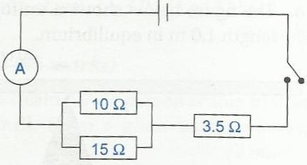

**Fig.6**

Fig **6** shows a circuit .The e.m.f of the battery is 2.1V and has an internal resistance of

0.5Ω.Determine the ammeter reading when the switch is closed. (03mks)

………………………………………………………………………………………………………………………………………………………………………………………………………………………………………………………………………………

………………………………………………………………………………………………………………………………………………………………………………………………………………………………………………………………………………

1. (a) Differentiate between the **node** and **antinode** as used in waves. (02mks)

………………………………………………………………………………………………………………………………………………………………………………………………………………………………………………………………………………

…………………………………………………………………………………………

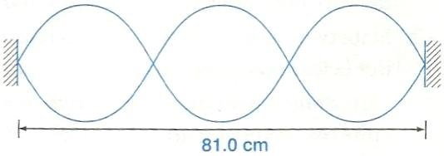(b)

**Fig 7**

Figure **7** shows a standing waves on a string of length 81.0cm.Determine the wave

length of the wave. (02mks)

………………………………………………………………………………………………………………………………………………………………………………………………………………………………………………………………………………

…………………………………………………………………………………………

1. (a) Define the term virtual image as applied in lenses. (01mk)

………………………………………………………………………………………………………………………………………………………………………………………………………………………………………………………………………………

(b) You are provided with the following apparatus.

* a convex lens
* a metre rule
* a screen
* a candle

1. Sketch a diagram of the set-up that can be used in determining the focal length by lens-formula method using the apparatus. (02mks)
2. State the measurement that can be taken during the experiment. (01mk)

………………………………………………………………………………………………………………………………………………………………………………………………………………………………………………………………………

………………………………………………………………………………………

1. (a) State the law relating the pressure and volume of a fixed mass of g as at constant

temperature. (01mk)

………………………………………………………………………………………………………………………………………………………………………………………………………………………………………………………………………………

…………………………………………………………………………………………

(b) 2000cm3 of a certain gas at 170c is heated at constant pressure until the volume

increases to 3000cm3.What is the new temperature of the gas. (03mks)

………………………………………………………………………………………………………………………………………………………………………………………………………………………………………………………………………………

…………………………………………………………………………………………

…………………………………………………………………………………………

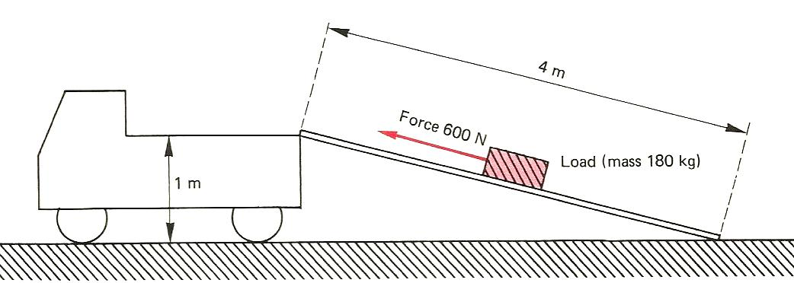

**Fig.8**

Fig **8** shows a ramp used to get a load which has a mass of 180kg.onto a lorry. The ramp is 4m long and the end of the lorry is 1m above the ground. A force of 600N is needed to pull the load up the ramp. Calculate

1. The gravitational potential energy gained by the load as it goes from the bottom to the top of the ramp. (02mks)

………………………………………………………………………………………………………………………………………………………………………………………………………………………………………………………………………………

…………………………………………………………………………………………

1. The work done by the 600N force in pulling the load up the ramp. (02mks)

………………………………………………………………………………………………………………………………………………………………………………………………………………………………………………………………………………

…………………………………………………………………………………………

…………………………………………………………………………………………

1. (a) (i) Define the term nuclear fusion. ( ½ mk)

……………………………………………………………………………………………………………………………………………………………………………………

…………………………………………………………………………………………

1. The following equation represents a nuclear fusion reaction

+ + find the value of a and b. (01mk)

………………………………………………………………………………………………………………………………………………………………………………………………………………………………………………………………………………

…………………………………………………………………………………………

1. Three radiations **A, B** and **C** are passed through electric field as shown in fig **9**.

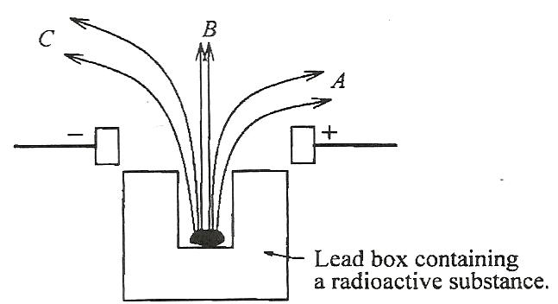

**Fig.9**

1. Identify the radiations (1 ½ mks)

A………………………………………………………………………………

B………………………………………………………………………………

C………………………………………………………………………………

1. (a) State Fleming’s left hand rule. (01mk)

………………………………………………………………………………………………………………………………………………………………………………………………………………………………………………………………………………

…………………………………………………………………………………………

1. Fig **10** below shows an arrangement that may be used to investigate how electromagnetic force varies with current.

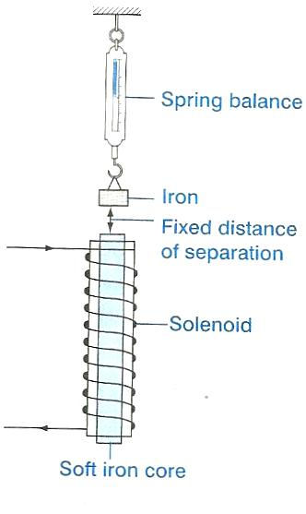

**Fig. 10**

1. Why is the current passed through the solenoid? (01mk)

………………………………………………………………………………………………………………………………………………………………………………………………………………………………………………………

1. What happens to the iron suspended from the spring balance when a current is passed through the solenoid? (01mk)

……………………………………………………………………………………………………………………………………………………………………

…………………………………………………………………………………

…………………………………………………………………………………

1. What is observed on the spring balance when the current passing through the solenoid is varied? (01mk)

………………………………………………………………………………………………………………………………………………………………………………………………………………………………………………………

…………………………………………………………………………………

1. (a) Define the term pressure as used in mechanics. (01mk)

………………………………………………………………………………………………………………………………………………………………………………………………………………………………………………………………………

1. Figure **11** below shows a paint spray gun

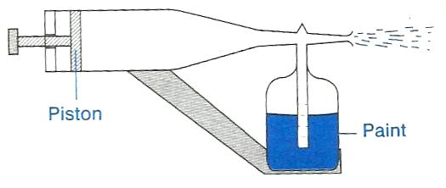

**Fig.11**

Explain briefly how the gun works. (03mks)

………………………………………………………………………………………………………………………………………………………………………………………………………………………………………………………………………………

…………………………………………………………………………………………

……………………………………………………………………………………………………………………………………………………………………………………

1. (a) You are provided with appositively charged electroscope, a glass rod and a silk duster.

State and explain what is observed when.

1. The glass rod is rubbed with the duster and then brought near the cap of the electroscope. (02mks)

………………………………………………………………………………………………………………………………………………………………………………………………………………………………………………………………………

………………………………………………………………………………………………………………………………………………………………………………

1. The duster and the rod are rubbed together then brought again near the cap. (02mks)

………………………………………………………………………………………………………………………………………………………………………………………………………………………………………………………………………

………………………………………………………………………………………

1. (a) Define the term **Kilowatt hour.** (01mk)

………………………………………………………………………………………………………………………………………………………………………………………………………………………………………………………………………

………………………………………………………………………………………

1. A laundry worker uses a 750 watt electric flat iron to press clothes for an average of

5 hours a week. What is the cost of electricity he uses in 4 weeks if electrical energy costs shs. 6.20 per **Kwh**?

(03mks)

………………………………………………………………………………………………………………………………………………………………………………………………………………………………………………………………………………

………………………………………………………………………………………………………………………………………………………………………………………………………………………………………………………………………………**END**