**273/2**

**GEOGRAPHY**

**Paper 2**

**Uganda Certificate of Education**

GEOGRAPHY

**Paper 2**

2 hours 30 minutes

**INSTRUCTIONS TO CANDIDATES:**

* *Answer* ***four*** *questions only.*
* *Choose* ***two*** *questions from* ***Part I*** *and* ***two*** *from* ***Part II****.*
* *In* ***Part II*** *only* ***one*** *question should be chosen from any* ***one*** *region.*
* *Any additional question(s) answered will not be marked.*

**Turn Over**

**PART 1: REST OF AFRICA**

*Answer* ***two*** *questions from this part*

1. (a) Draw a sketch map of Africa and on it mark and name;

(i) the Great African rift valley.

(ii) Highlands; Tibesti and Cape ranges.

(iii) Rivers; Olifants ad Niger.

(iv) Chad Basin. (08 marks)

(b) Describe the process that led to the formation of rift valley. (05 marks)

(c) Explain the benefits of the rift valley to the people in the surrounding areas.

(08 marks)

(d) Outline the challenges faced by the people living within the rift valley region.

(04 marks)

2. (a) Draw a sketch map of Africa and on it mark and name;

(i) water bodies; Red Sea and the Atlantic Ocean.

(ii) rivers; Congo (Zaire) and Nile.

(iii) two areas of high population density.

(iv) one area of low population density. (07 marks)

(b) Describe the conditions which have led to high population density in any one area identified in (a) above. (06 marks)

(c) Explain the problems which are faced in areas of high population density in Africa. (08 marks)

(d) Outline the steps being taken to solve the problems identified in (c) above.

(04 marks)

3. Study Fig I: Map of Gabon provided below showing forests and answer the questions that follow.

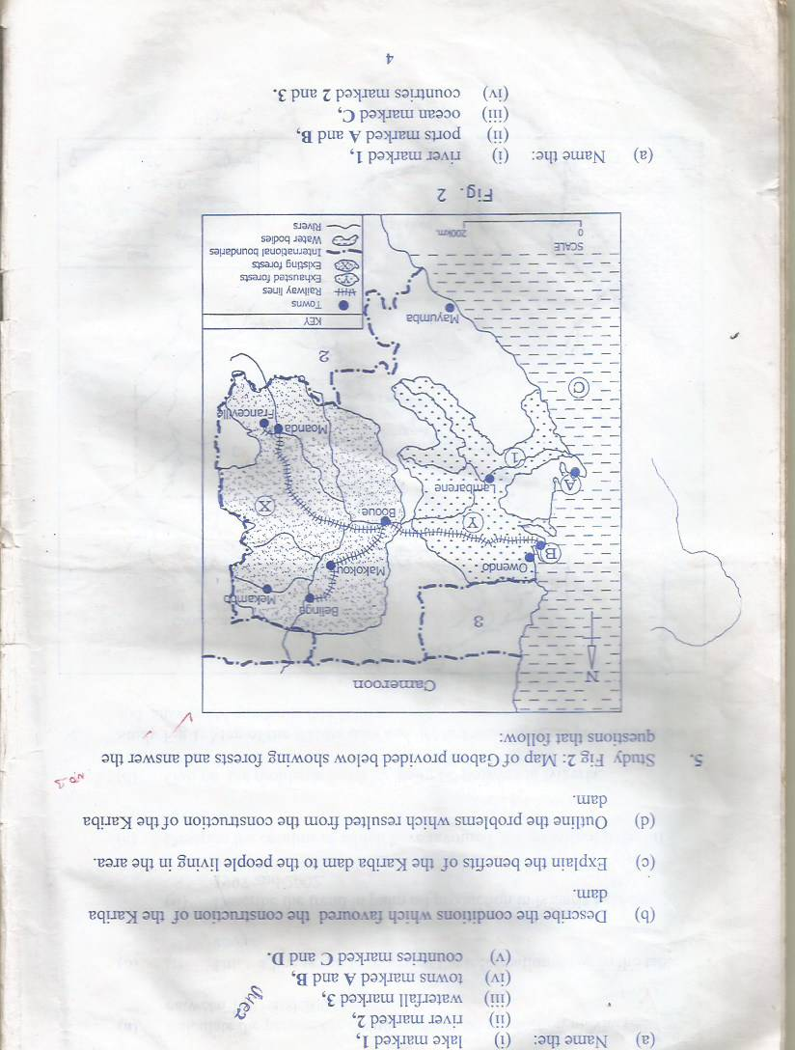

(a) Name the ;

(i) river marked 1

(ii) ports marked A and B.

(iii) ocean marked C.

(iv) countries marked 2 and 3. (06 marks)

(b) Describe the factors which have favoured forestry activities in area marked X.

(06 marks)

(c) Explain the effects of over exploitation of forests in area marked Y.

(08 marks)

(d) Outline the benefits of the forestry industry to the development of Gabon.

(05 marks)

4. Read the passage below and answer the questions that follow.

“Africa would appear at first sight to posses considerable advantage for the development of the fishing industry …………. yet it is unfortunately true that the African share of the total world catch of fish is temitaries actually import fish.”

***(Source: Jarreh H.R Africa; The New Certificate Geography 5th Edition P99)***

(a) Describe the factors which “appear” to favour the development of the fishing industry in Africa. (06 marks)

(b) Explain the conditions responsible for the low level of development of the fishing industry in Africa. (08 marks)

(c) (i) State two countries in Africa which export fish. (02 marks)

(ii) For any one country stated in (c)(i) above, identify the steps being taken to improve the fishing industry. (06 marks)

(d) Identify any three modern methods of catching fish. (03 marks)

**PART II: STUDIES IN DEVELOPMENT**

*Answer* ***two*** *questions from this part*

**REGION I: NORTH AMERICA**

5. (a) Draw a sketch map of the British Columbia and on it mark and name the following

(i) Mineral areas coal and petroleum.

(ii) Canadian Pacific railway.

(iii) Bordering provinces of Alberta and Yukon.

(iv) Towns; Kitimat and Victoria. (08 marks)

(b) Describe factors that have favoured the mining sector in British Coumbia. (06 marks)

(c) Explain the problems facing the mining sector in British Columbia. (06 marks)

(d) Outline the steps being taken to solve the above problem. (05 marks)

6. (a) Name any three

(i) states under the Tennessee Valley Authority. (03 marks)

(ii) rivers draining the area under the Tennessee Valley Authority.

(03 marks)

(b) Describe the conditions which led to the establishment of the Tennessee Valley authority in the states above. (06 marks)

(c) Outline the activities of the Tennessee Valley Authority in the states above.

(06 marks)

(d) Explain the benefits of the Tennessee Valley Authority to the United States of America. (08 marks)

7. Study table 1 below showing the Cargo entering the great lakes 1950 – 2000 and answer the questions that follow.

|  |  |
| --- | --- |
| **Year** | **Cargo(000 metric tones)** |
| **1950** | **124000** |
| **1960** | **137000** |
| **1970** | **242000** |
| **1980** | **280000** |
| **1990** | **314000** |
| **2000** | **370000** |

(a) Draw a line graph to show the cargo entering the Great Lakes before 1950 and 2000. (08 marks)

(b) Describe the

(i) trend of cargo entering the great lakes between 1950 and 2000.

(02 marks)

(ii) conditions which led to the construction of the St. Lawrence Seaway and power project. (06 marks)

(c) Explain the benefits of the St. Lawrence Seaway to U.S.A and Canada.

(06 marks)

(d) Outline the problems still faced by the St. Lawrence Seaway. (03 marks)

**REGION II: RHINELANDS**

8. Study table II showing incoming international tourists to Switzerland in 2009 and answer the questions that follow.

|  |  |
| --- | --- |
| **Country** | **Incoming tourists in(000s)** |
| Germany | 1,350 |
| U.S.A | 18,247 |
| Italy | 2,403 |
| Netherlands | 15,400 |
| Canada | 1,280 |

(a) Draw a bar graph to show the trend of the incoming international tourists to Switzerland. (08 marks)

(b) (i) Identify any three tourists attractions in the Swiss Alps. (03 marks)

(ii) Describe any four factors favoring tourism activities in Alps. (04 marks)

(c) What are the problems facing the tourism industry in the Alpine region.

(04 marks)

(d) Explain steps have been taken to solve the problems named in (c) above?

(06 marks)

9. Study Fig. Map of Belgium provided below and answer the questions that follow.

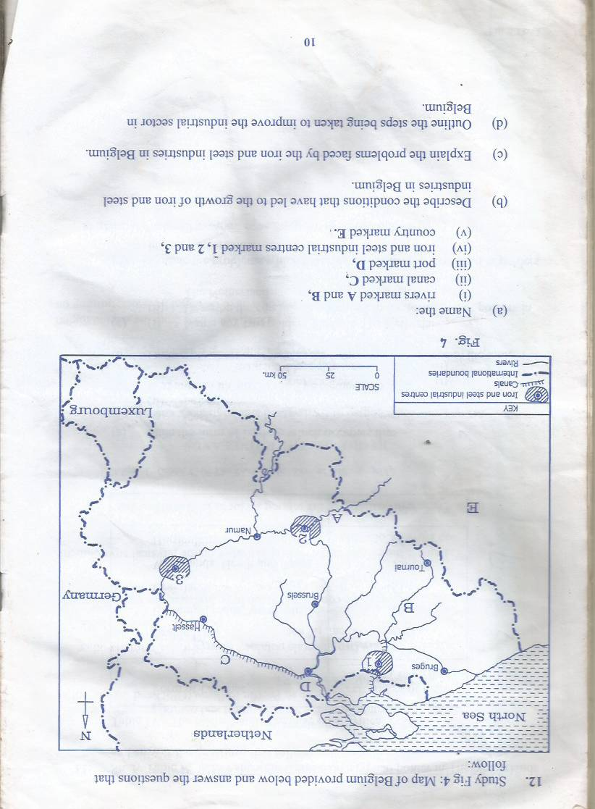

(a) Name the;

(i) Rivers marked A and B.

(ii) Canal marked C.

(iii) Port marked D

(iv) Iron and steel industrial centres marked 1, 2 and 3.

(v) Country marked E. (08 marks)

(b) Describe the conditions that have led to the growth of iron and steel industries in Belgium. (06 marks)

(c) Explain the problems faced by the iron and steel industries in Belgium.

(06 marks)

(d) Outline the steps taken to improve the industrial section in Belgium.

(05 marks)

10. Draw a sketch map of the Ruhr coal field and on it mark and name.

(a) (i) Exposed coal field.

(ii) Concealed coal field.

(iii) Dortmund – EMS – Canal.

(iv) Rivers Lippe and Wuppertal.

(v) Towns; Bochum and Essen. (08 marks)

(b) Describe the factors that have favoured coal mining in the Ruhr region.

(06 marks)

(c) Explain the importance of coal mining in the Ruhr coal mines. (06 marks)

(d) Outline problems facing the Ruhr Coal Fields. (05 marks)

**REGION III: CHINA**

11. Study table III below showing China’s manufacturing sector and answer the questions that follow.

**TABLE III: CHINA STRUCTURE OF MANUFACTURING SECTOR (2001)**

|  |  |
| --- | --- |
| **Manufacturing industry** | **Percentage** |
| Food and beverages | 15 |
| Tobacco |  |
| Textiles and clothing | 12 |
| Machinery and transport equipment | 32 |
| Chemicals | 12 |
| Other manufacturing | 29 |
| Total | 100 |

(a) Draw a pie chart to represent the information given in the table. (10 marks)

(b) (i) Identify the largest manufacturing sector in china. (01 mark)

(ii) Describe the factors which have led to the development of the manufacturing section to the development of China. (05 marks)

(c) Explain the benefits of the manufacturing sector to the development of China.

(06 marks)

(d) Outline the effects of industrialization on the physical environment.

(03 marks)

12. (a) What is meant by the term Entreport? (02 marks)

(b) Describe the conditions which have favoured the development of Hong Kong as an Entreport. (08 marks)

(c) Identify the contributions of Hong Kong entreport to the development of China.

(06 marks)

(d) Explain the;

(i) Problems affecting Hong Kong entreport. (05 marks)

(ii) measures being taken to solve the problems in (d) (i) above. (04 marks)

13. Study table below showing Bauxite production in selected areas of China in 2014 ad answer the questions that follow.

**TABLE IV**

|  |  |
| --- | --- |
| **Area** | **Production** |
| Shandong | 34,207 |
| Dongfung | 16,282 |
| Shanxi | 8,750 |
| Fushun | 7,702 |
| Shenyang | 4,600 |
| Henan | 3,459 |

(a) Draw a pie chart to show relative importance of Bauxite production in China.

(12 marks)

(b) Describe the conditions favouring the growth of the mining sector in China.

(06 marks)

(c) Outline the effects of the mining sector on the physical environment in China.

(05 marks)

(d) State any other two minerals exploited in China. (02 marks)

***END***